♥ ♥ ♥ ♥ ♥ ♥
Knitted Ice Cream Tub Cribs
Please can they be made in gender neutral colours, preferably white, cream, ivory. (please no pink or blue) and the same for any embellishments you may like to add. Thank you.
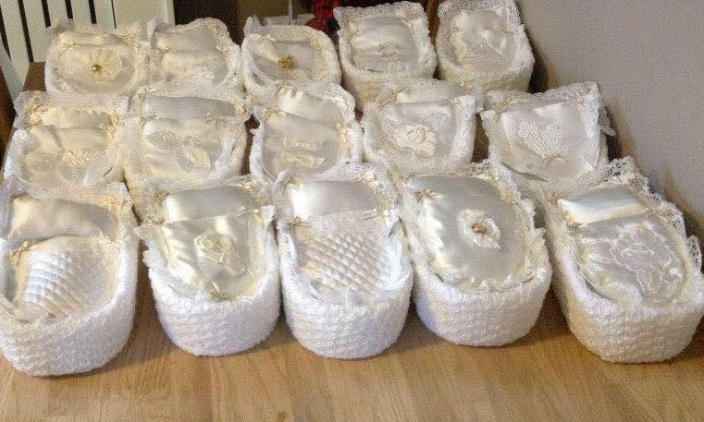
Doreen Barker's Posh Angel crib Knitting Pattern
Pattern courtesy of Preemies UK
Double Knitting 4mm needles
Blanket
Cast on 24sts
1st Row: K2 P2 across
2nd Row: K2 P2 across
3rd Row: P2 K2 across
4th Row: P2 K2 across
Repeat the last 4 Rows 8 Times
Stocking Stitch for 10 Rows ( Knit 1 row, Purl 1 Row)
Cast off
This will make them hem fold this 10 rows in half and sew it across.
Pillow
Cast on 24sts
1st Row: K2 P2 across
2nd Row: K2 P2 across
3rd Row: P2 K2 across
4th Row: P2 K2 across
Repeat this 6 times
Stocking Stitch for 8 Rows ( Knit 1 row, Purl 1 Row)
Cast off
This will make this in half and sew across and fill with toy filling and sew the opening closed
Outer Cover
Cast on 86sts
1st Row: K2* P2* across Knit the last 2 sts
2nd Row: K2* K2 P2* across knit the last 4 sts
3rd Row: K2* K2 P2* across Knit the last 4 sts
4th Row: K2* P2 K2* P2 K2 across
Work unit its 5 inches
Cast off
Base/ inside Cover Make 2 (one for the bottom and one for inside)
Cast on 13sts
1st Row: Increase 1 stitch, knit to the end increase the last stitch
2nd Row: Knit across
Repeat these 2 rows : until you have 23sts in Garter Stitch
Work until 52 rows has been worked from the begining
1st row: Decrease 1st the stitch and the begining and end.
2nd Row: Knit row
Repeat these 2 rows: Until you have 13sts are left
Cast off
Mattress (Make 2)
Cast on 15 stitches
Row 1: knit
Row 2: purl
Row 3: k1f&b, knit to last stitch, k1f&b (17 stitches)
Row 4: purl
Repeat rows 3 and 4 a further 5 times (27 stitches)
Continue in stocking stitch without the increases for a further 24 rows
Row 39: k2tog, knit to last 2 stitches, k2tog, (25 stitches)
Row 40: purl
Repeat rows 39 and 40 a further 5 times (15 stitches)
Row 51: knit
Row 52: purl
Cast off
Place 2 pieces right sides together. Sew around 3 sides. Stuff, and then sew remaining side.
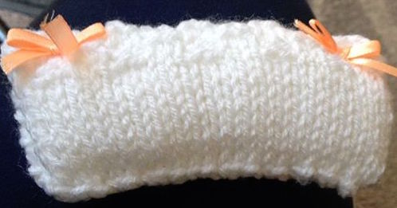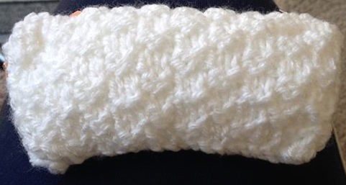

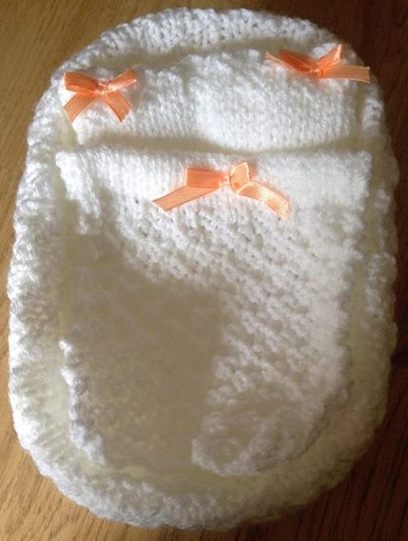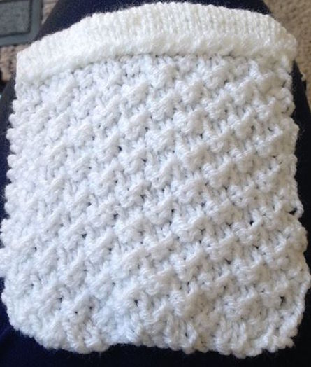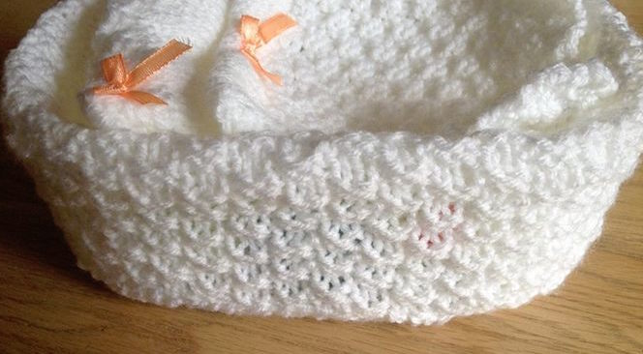

♥ ♥ ♥ ♥ ♥ ♥

Wendy Knitted Crib
Pattern courtesy of Premies UK
1 x 100g double knitting ( there will be some left over)
4mm/ old sizes 8 for every other piece except pillow which uses 2 3/4mm old size 12
Crib is worked in every row Knit and is a close fit to the crib
CARTE DOR ICE CREAM TUBS are used but all ice cream tubs this size will be prefect
Main piece
fits up and over sides of tub from bottom outer to bottom inner base
Cast on 88 sts
Knit 46 rows
Oversew short sides together and turn piece so the seam is inside
place on to the tub
Base Linings - Make 2
Cast on 13sts
Increase at each end of next and following alternative row until there is 23sts on the needle
Continue knitting every row until 52 rows have been completed from the start
Decrease 1st at each end of the next and following alternative row until there is 13sts on the needle
Cast off
Pin one base piece to the outer bottom of tub and oversew into place
Pin the other base piece to the inner bottom of the tub and oversew in to place
Blanket
Cast on 43sts
Knit 44 rows
cast off
Pillow
Use 2 3/4mm (old size 12 needles)
Cast on 46sts
Knit 56 Rows
Cast off
Fold over piece to join the cast on edge.
Oversew this seam and turn piece through to the right side
Stuff and oversew the open edge
Mattress (Make 2)
Cast on 15 stitches
Row 1: knit
Row 2: purl
Row 3: k1f&b, knit to last stitch, k1f&b (17 stitches)
Row 4: purl
Repeat rows 3 and 4 a further 5 times (27 stitches)
Continue in stocking stitch without the increases for a further 24 rows
Row 39: k2tog, knit to last 2 stitches, k2tog, (25 stitches)
Row 40: purl
Repeat rows 39 and 40 a further 5 times (15 stitches)
Row 51: knit
Row 52: purl
Cast off
Place 2 pieces right sides together. Sew around 3 sides. Stuff, and then sew remaining side.

