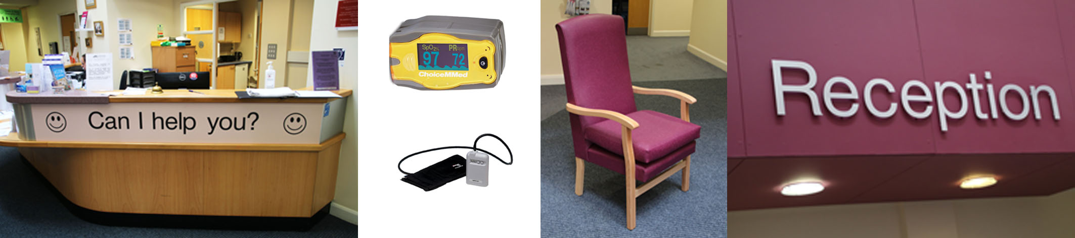
Haddenham Patient Group - PPG 200 Club Lottery 2019
In 2018 the PPG 200 Club purchased for the Haddenham Medical Centre a Fingertip Pulse Oximeter (Paediatric), 2 Multi Reading/Recording BP monitors and 2 additional High-Backed Armchairs for reception. The PPG also worked on new dementia friendly signage project with the Medical Centre. The first stage of this project has now been installed. The cost of the full project is going to be in excess of £3,000 and has been made possible by generous grants from the Haddenham Beer Festival Trust and the Haddenham Fete Committee.
The PPG is also planning to run events in 2019 dealing with some of the more pressing health and related issues of today. In the Spring of 2019 we will stage a playlet called “Connie’s Colander” which deals Dementia and will be performed at the library.
Please help support our 2019 programme by joining PPG 200 Club Lottery.
Members can register online at www.hmcppg.com/ppg.php or complete the form below.
✂————————————————————————————————————————————————————————————

Haddenham Medical Centre PPG 200 Club 2019 - Cash Prizes every Month!
£50, £25 & £10 Prizes every Month. Annual subscription £25 per member
I would like to register for the PPG 200 Club 2019 and will send my subscription of £25 by cheque or bank transfer before the end of January 2019

First Name |  | Surname
Address
Email
Tel No. |  | Mobile No:
Signature |  | Date

Please return form to Lesley Coles, 52 Stokes End, Haddenham, HP17 8DX or contact for further information tel: 07711 832898 / email lesleycoles.uk@googlemail.com
Payment by cheque or bank transfer payable to PPG 200 CLUB.
Transfer sort code 40-08-39 a/c no. 22083892 with your name in the reference box

