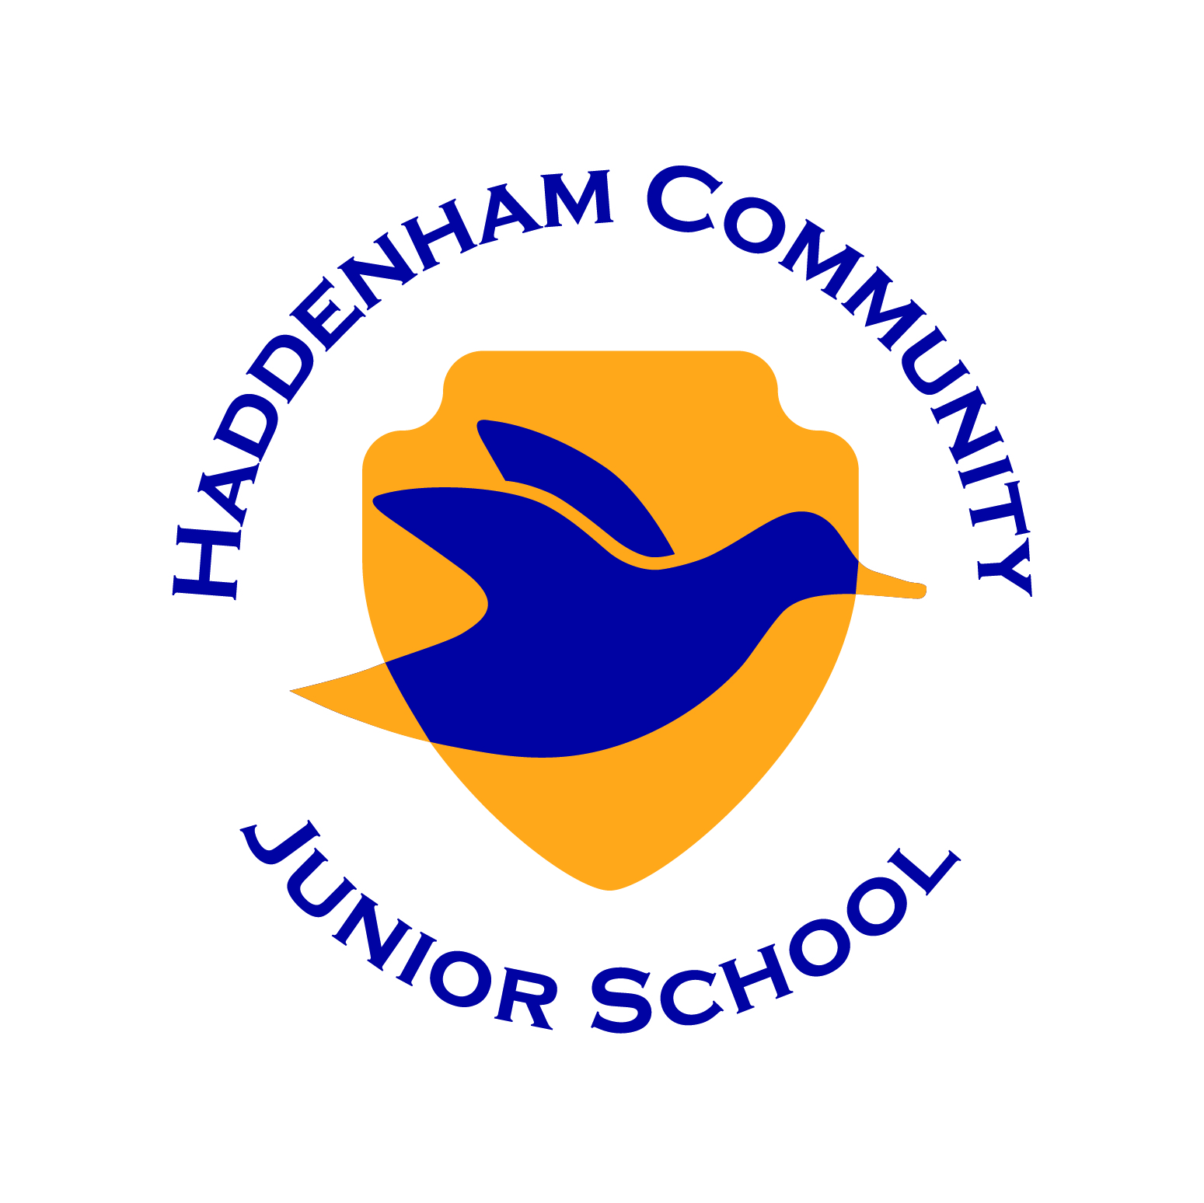
Woodways Haddenham Aylesbury
Bucks HP17 8DS
Tel: 01844 291829
Chairs of Governors: Mrs. J Atkin and Ms. J Clarke
Headteacher: Mr A. Leach
E-mail: office@haddenhamjun.co.uk

Aiming High, Celebrating Success

2nd October 2018

Dear Parents and Guardians,
We are very pleased that we can now let you know the outcome of our Ofsted inspection. The attached report from the Inspector confirms our status as a Good school.
Some of the very positive highlights from the report include:
''Relationships between staff and children are excellent.''
''Pupils receive high-quality pastoral care which enables them to flourish and learn well together.''
''Pupils are very proud of this school and describe their school as 'fantastic', 'exciting' and 'unique'.''
''Safe-guarding is at the heart of the school culture.''
''The proportion of pupils making strong progress [in writing] is improving rapidly.''
We are justly proud of the achievements and progress that have been made since the previous inspection in 2014 and will continue to work to offer your children a well-rounded, stimulating and quality education and to help prepare them for their next stage of education beyond HCJS.
Congratulations to all staff for their hard work and commitment to the school and to your children's education. Thank you too for your ongoing support and for all of you who took time on the eve of Ofsted's arrival to comment on the ParentView site. The Inspector highlights the very strong ethos of teamwork that is evident in the school. We look forward to working collectively - staff, governors, parents and pupils - and within our wider community over the years to come.
With best regards,

Andy Leach, Headteacher
Jessica Clarke & Alysoun Glasspool, Co-Chairs Governing Board

